**Object Oriented Programming**

**Tutorial 03**

1)

**package** iit.tutorial3_1.sachintha;

**public class** Cylinder **extends** Circle {  
 **private double height**;  
  
 *// Constructor with default color, radius and height* **public** Cylinder(){  
 **super**();  
 **height** = 1.0;  
 }  
  
 *// Constructor with default radius, color but given height* **public** Cylinder(**double** height){  
 **super**();  
 **this**.**height** = height;  
 }  
  
 *// Constructor with default color, but given radius, height* **public** Cylinder(**double** radius , **double** height){  
 **super**(radius);  
 **this**.**height** = height;  
 }  
  
 *// A public method for retrieving the height* **public double** getHeight() {  
 **return height**;  
 }  
  
 *// A public method for computing the volume of cylinder  
 // use superclass method getArea() to get the base area* **public double** getVolume(){  
 **double** volume = getArea()\***height**;  
 **return** volume;  
 }  
}

2)

**package** iit.tutorial3_1.sachintha;

**public class** TestCylinder {  
 **public static void** main(String[] args) {  
  
 *// Declare and allocate a new instance of cylinder* Cylinder c1 = **new** Cylinder();  
  
 System.***out***.println(**"Cylinder:"** + **" radius = "** + c1.getRadius()  
 + **" height = "** + c1.getHeight() + **" base area = "** + c1.getArea() + **" volume = "** + c1.getVolume());  
  
 *// Declare and allocatea new instance of cylinder, specifying Height* Cylinder c2 = **new** Cylinder(5.0);  
  
 System.***out***.println(**"Cylinder:"** + **" radius = "** + c2.getRadius()  
 + **" height = "** + c2.getHeight() + **" base area = "** + c2.getArea() + **" volume = "** + c2.getVolume());  
  
 *// Declare and allocatea new instance of cylinder, specifying Height and height* Cylinder c3 = **new** Cylinder(5.0, 10.0);  
  
 System.***out***.println(**"Cylinder:"** + **" radius = "** + c3.getRadius()  
 + **" height = "** + c3.getHeight() + **" base area = "** + c3.getArea() + **" volume = "** + c3.getVolume());  
 }  
}

3)

*// A public method calculate and return to cylinder area***public double** getArea(){  
 **return** (2*Math.***PI***\*getRadius()\***height**)+(2\***super**.getArea());  
}

4)

*// Declare and allocate a new instance of circle*Circle c4 = **new** Circle();  
  
System.***out***.println(**"c4 Circle Area = "**+c4.getArea());  
  
*// Declare and allocate a new instance of cylinder*Cylinder c5 = **new** Cylinder();  
  
System.***out***.println(**"c5 Cylinder Area = "**+c5.getArea());

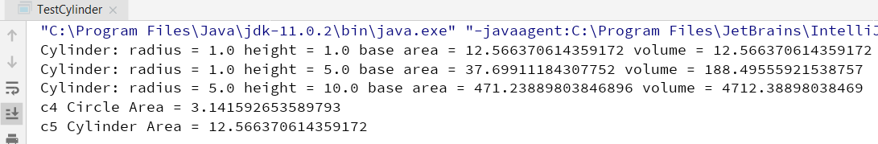

5)

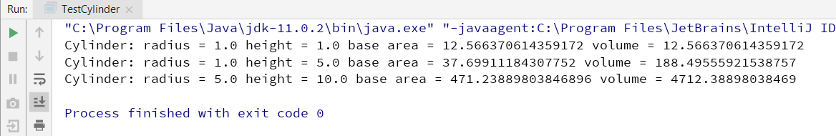

*// A public method for computing the volume of cylinder  
// use superclass method getArea() to get the base area***public double** getVolume(){  
 **double** volume = **super**.getArea()\***height**;  
 **return** volume;  
}

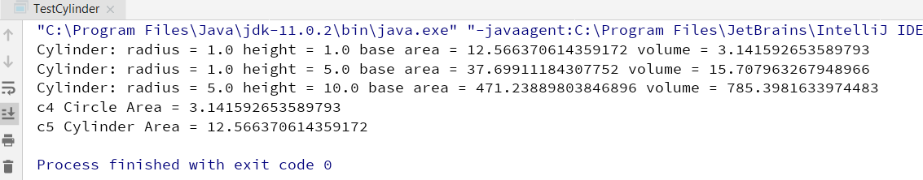

6)

*// in Cylinder class*@Override  
**public** String toString() {  
 **return "Cylinder: subclass of "** + **super**.toString()  
 + **" height = "** + **height**;  
}

*// Declare and allocate a new instance of cylinder* Cylinder c5 = **new** Cylinder();  
  
 System.***out***.println(**"c5 Cylinder Area = "**+c5.getArea());  
  
 System.***out***.println(c5.toString());  
}

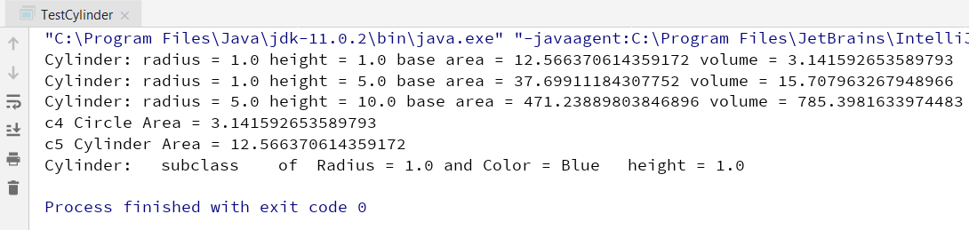

7)

**package** iit.tutorial3_2.sachintha;  
  
**public class** Person {  
 **protected** String **myName** ; *// name of the person* **protected int myAge**; *// person’s age* **protected** String **myGender**; *// “M” for male, “F” for female* **public** Person(String name, **int** age, String gender) {  
 **myName** = name;  
 **myAge** = age ;  
 **myGender** = gender;  
 }  
  
 @Override  
 **public** String toString() {  
 **return "Person{"** +  
 **"myName='"** + **myName** + **'\''** +  
 **", myAge="** + **myAge** +  
 **", myGender='"** + **myGender** + **'\''** +  
 **'}'**;  
 }

**public** String getMyName() {  
 **return myName**;  
 }  
  
 **public void** setMyName(String myName) {  
 **this**.**myName** = myName;  
 }  
  
 **public int** getMyAge() {  
 **return myAge**;  
 }  
  
 **public void** setMyAge(**int** myAge) {  
 **this**.**myAge** = myAge;  
 }  
  
 **public** String getMyGender() {  
 **return myGender**;  
 }  
  
 **public void** setMyGender(String myGender) {  
 **this**.**myGender** = myGender;  
 }  
}

8)

**package** iit.tutorial3_2.sachintha;  
  
**public class** Student **extends** Person {  
 **private int idNumber**; *//student id number* **private double fee**; *// student fees* **private int grade**; *// student grade  
  
 // constructor for student* Student(String name, **int** age , String gender, **int** idNumber){  
 **super**(name,age,gender);  
 **this**.**idNumber** = idNumber;  
 }  
  
 **public int** getIdNumber() {  
 **return idNumber**;  
 }  
  
 **public void** setIdNumber(**int** idNumber) {  
 **this**.**idNumber** = idNumber;  
 }  
  
 **public double** getFee() {  
 **return fee**;  
 }  
  
 **public void** setFee(**double** fee) {  
 **this**.**fee** = fee;  
 }  
  
 **public int** getGrade() {  
 **return grade**;  
 }  
  
 **public void** setGrade(**int** grade) {  
 **this**.**grade** = grade;  
 }  
  
  
 @Override  
 **public** String toString() {  
 **return "Student{"** +  
 **super**.toString() +  
 **"idNumber="** + **idNumber** +  
 **", fee="** + **fee** +  
 **", grade="** + **grade** +  
 **"} "**;  
 }  
}

9)

**package** iit.tutorial3_2.sachintha;  
  
**public class** Teacher **extends** Person {  
   
 **private double salary**; *// teacher's salary* **private** String **subject**; *// teacher's subject* Teacher(String name , **int** age, String gender , String subject, **double** salary){  
 **super**(name ,age, gender);  
 **this**.**subject** = subject;  
 **this**.**salary** = salary;  
 }  
  
 **public double** getSalary() {  
 **return salary**;  
 }  
  
 **public void** setSalary(**double** salary) {  
 **this**.**salary** = salary;  
 }  
  
 **public** String getSubject() {  
 **return subject**;  
 }  
  
 **public void** setSubject(String subject) {  
 **this**.**subject** = subject;  
 }  
  
 @Override  
 **public** String toString() {  
 **return "Teacher{"** +  
 **super**.toString()+  
 **"salary="** + **salary** +  
 **", subject='"** + **subject** + **'\''** +  
 **"} "** ;  
 }  
}

10)

**package** iit.tutorial3_2.sachintha;  
  
**public class** TestPerson {  
 **public static void** main(String[] args) {  
 Person jack = **new** Person(**"Jack Brooke"**, 27, **"M"**);  
 System.***out***.println(jack);  
 Student beth = **new** Student(**"Elisabeth Smith"**, 16, **"F"**, 122233);  
 System.***out***.println(beth);  
 Teacher sam = **new** Teacher(**"Sam Hamilton"**, 34, **"M"**, **"Computer Science"**, 50000);  
 System.***out***.println(sam);  
 }  
}

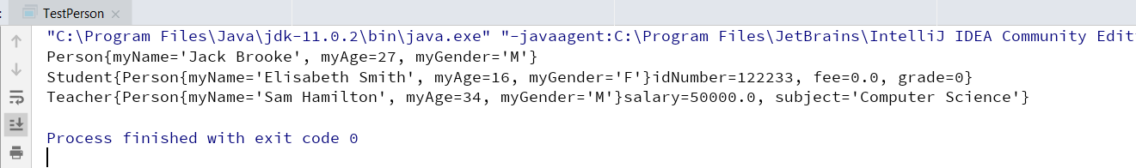

11)

Person p = **new** Teacher (**"Sam Hamilton"**, 34, **"M"**, **"Computer Science"**, 50000);  
Teacher t = **new** Person (**"Sam Hamilton"**, 34, **"M"**, **"Computer Science"**, 50000);  
Person s = **new** Student (**"Elisabeth Smith"**, 16, **"F"**, 122233);

